
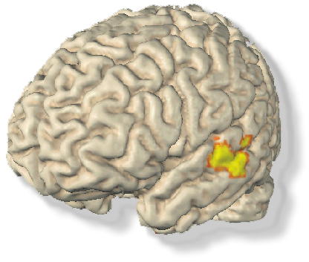
Are you playing a
Musical instrument?
Then you could earn $20 per hour!!!

We are recruiting healthy musicians to participate in an auditory neuroimaging study.

You should:
- have started to play an instrument before the age of 7
- be between 18-30 years of age

If you are interested call Katrin Schulze at the Beth Israel Deaconess Medical Center.
phone: 617- 632- 8922
or e-mail: bidmc_musicresearch@yahoo.com

Katrin Schulze
617- 632- 8922
bidmc_musicresearch@yahoo.com
Katrin Schulze
617- 632- 8922
bidmc_musicresearch@yahoo.com
Katrin Schulze
617- 632- 8922
bidmc_musicresearch@yahoo.com
Katrin Schulze
617- 632- 8922
bidmc_musicresearch@yahoo.com
Katrin Schulze
617- 632- 8922
bidmc_musicresearch@yahoo.com
Katrin Schulze
617- 632- 8922
bidmc_musicresearch@yahoo.com
Katrin Schulze
617- 632- 8922
bidmc_musicresearch@yahoo.com

