
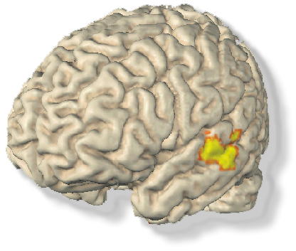
Are you tone deaf?

- Can´t sing a single note in tune?
- Can´t remember or recognize melodies which are familiar to other people?
- Suffer from an inability to recognize or perceive music, sing or dance, although you had musical lessons during your childhood?
- Have no hearing impairments?
Then you could earn $20 per hour!!!
If you are interested call Katrin Schulze at the Beth Israel Deaconess Medical Center.
phone: 617- 632- 8922.
or e-mail: bidmc_musicresearch@yahoo.com
Katrin
617- 632- 8922
bidmc_musicresearch@yahoo.com
Katrin
617- 632- 8922
bidmc_musicresearch@yahoo.com
Katrin
617- 632- 8922
bidmc_musicresearch@yahoo.com
Katrin
617- 632- 8922
bidmc_musicresearch@yahoo.com
Katrin
617- 632- 8922
bidmc_musicresearch@yahoo.com
Katrin
617- 632- 8922
bidmc_musicresearch@yahoo.com
Katrin
617- 632- 8922
bidmc_musicresearch@yahoo.com

