
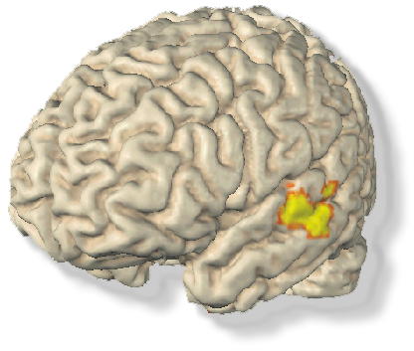
Do you have
Absolute PITCH?

Then you could earn $20 per hour!!!

We are recruiting healthy volunteers who have perfect pitch to participate in an auditory neuroimaging study.

You should:
- be between 18-30 years of age
- have perfect pitch.

If you are interested call Katrin or Nadine at the Beth Israel Deaconess Medical Center.
phone: 617- 632- 8922.
or e-mail: bidmc_musicresearch@yahoo.com

